**GOVERNMENT DEGREE COLLEGE, GUMMALAKSHMIPURAM**

**DEPARTMENT OF BOTANY 2024**

**Name of the Activity: Kitchen Garden**

**Kitchen Gardening**

**Abstract:**

**A kitchen garden is a part of a garden or yard where we grow vegetables and fruits for our own use. It creates a feeling of satisfaction and enjoyment in harvesting fruits of one’s own hard work and Students. Raising fresh vegetables rich in nutrients to supply the family the whole year round. Proper utilization of land in the vicinity of the house. With this, kitchen water and waste can be utilized efficiently and effectively. The basic principles to be considered while planning are as follows:**

**Appropriate size and shape will depend on the family size. It is better to have a small size well maintained garden than a poorly maintained large one. Location is the fundamental principle and it should be close to the house. Suitable and convenient layout should be maintained. Open and sunny site is required as sunlight is very important for proper growth of plants. Site should be free from shade trees, etc. Suitable and effective rotations should be followed to make best use of the available land.**

**Key words: Kitchen, Gardening, Utilization of waste, Site selection, Basic principles.**

**Introduction:**

**In this fast paced world, many people need a way to relax and unwind. Gardening is a perfect hobby to do so. Many people like gardening for many different reasons. It is an activity you can share with your spouse, kids, friends, family or neighboursor staff members or students. It is a great activity to get you out of the house. Plus it is a productive way to spend precious free time. Growing your own food helps the environment in many ways. The biggest way you can help the environment when gardening, is by having a green garden (or kitchen garden). There are many things you can do to achieve this. It is mostly done in organic way that’s why it is termed as “Green garden”. When you grow your own food, you get the freshest items possible.**

**What is kitchen gardening:**

**Kitchen garden is the growing of fruits and vegetables at the backyard of house using kitchen waste water. Otherwise called as Home garden or Nutrition garden or Kitchen gardening or Vegetable gardening. It is a space separate from the rest of the residential garden (the ornamental plants and lawn areas). It is used for growing plants for eating, flavoring food, and often some medicinal plants. The plants are grown for use by the owner and their household, though some seasonal surpluses are given away or sold; a commercial operation growing a variety of vegetables is a market garden (or a farm).**

**What are the steps to set up the kitchen garden?**

1. **Site selection:**

**1. Usually the best place for selection of kitchen garden is the backyard of the house.**

**2. This is convenient as the members of the family can give a constant care to the vegetables during leisure and the wastewater from the bathrooms and kitchen can easily be diverted to the vegetable beds.**

**3. The size of a kitchen garden depends upon the availability of land and number of persons for whom vegetables are to be provided.**

**4. Five cents of land would be adequate to supply vegetables for an average family of four to five persons.**

**B) Land preparation:**

**1. Firstly a through spade digging is made to a depth of 30-40 cm.**

**2. Stones, bushes and perennial weeds are removed.**

**3. 100 kg of well decomposed farmyard manure or vermicompost is applied and mixed with the soil.**

**4. Ridges and furrows are formed at a spacing of 45 cm or 60 cm as per the requirement.**

**5. Flat beds can also be formed instead of ridges and furrows.**

**C) Sowing and planting:**

**1. Direct sown crops like bhendi, cluster beans and cowpea can be sown on one side of the ridges at a spacing of 30 cm. Amaranthus can be sown after mixing 1 part of seeds with 20 parts of fine sand by broadcasting in the plots. Small onion, mint and**

**Coriander can be planted/sown along the bunds of plots.**

**2. Seeds of transplanted crops like tomato, brinjal and chili can be sown in nursery beds or pots one month in advance by drawing lines.**

**3. The perennial plants should be located on one side of the garden, usually on the rear end of the garden so that they may not shade other crops, compete for nutrition with the other vegetable crops.**

**How to maintain a vegetable garden:**

**Vegetable plants expend an enormous amount of energy on blooming and producing fruit that never gets to mature as far as the plants are concerned. A plant sets fruit so it can produce seed, but we tend to harvest vegetables before the seeds are fully formed. This is stressful for vegetable plants, so it's important to give them what they need for the health and vigor to keep producing.**

**Neglect can also lead to lower yields and inferior vegetables due to more pest problems.**

**i) Water Your Garden Regularly**

**Regularly water your plants. Without regular water, vegetables will not fill out and some, like tomatoes, will crack open if suddenly plumped up with water after struggling without for awhile. You can’t always relay on rain, if possible drip irrigation is recommended. So that it delivers water directly to the plant roots.**

**ii) Maintain Your Vegetable Plants**

**For plants that are direct-sown from seed, removing excess seedlings is an essential step for a healthy vegetable garden. This is called thinning. Once true leaves appear, remove seedlings so the remaining plants are at the recommended spacing distances.**

**Another maintenance task to perform early in the gardening season is staking plants. Tall and climbing vegetables require some sort of staking or trellising. It's best to install the stakes at planting time. Later in the season, suckers should be pruned from tomatoes. Pruning tomato suckers means removing the growth that appears between where the stem and a branch meet. If left to grow, they will become another main stem with branches, flowers, fruit, and more suckers of their own, competing for nutrients with the original plant.**

**iii) Remove weeds**

**Vegetables don't like to compete with weeds for food and water. In addition to manually removing weeds from your garden itself, it's important to remove weeds from surrounding pathways and grass as well; if they're allowed to go to seed, those seeds might end up in your garden.**

**If you keep weeds in check from the beginning of the gardening season, you shouldn't need to resort to herbicides later in the summer.**

**iv) Add Mulch**

**Mulching is one of the best things you can do for your plants. It suppresses weeds, cools plant roots, and conserves water. Sometimes the plants themselves can serve as a living mulch if they grow dense enough.**

**The preferred mulch for vegetable gardens is seed-free straw. It makes a nice cover, it's easy enough to push aside for planting and it can be turned into the soil at the end of the season.**

**v) Enrich the Soil**

**Vegetables are heavy feeders. You should work some organic matter into the garden each year before planting and side-dress with more organic matter once or twice during the growing season. Different plants have different needs, of course, so it's important to take note of any fertilizing instructions that came with your seedlings or on the back of your seed packets.**

**Organic plant foods are slow releasing and will continue to feed your plants all season long. If you do opt for a water-soluble fertilizer, make sure your garden is well-watered before applying it.**

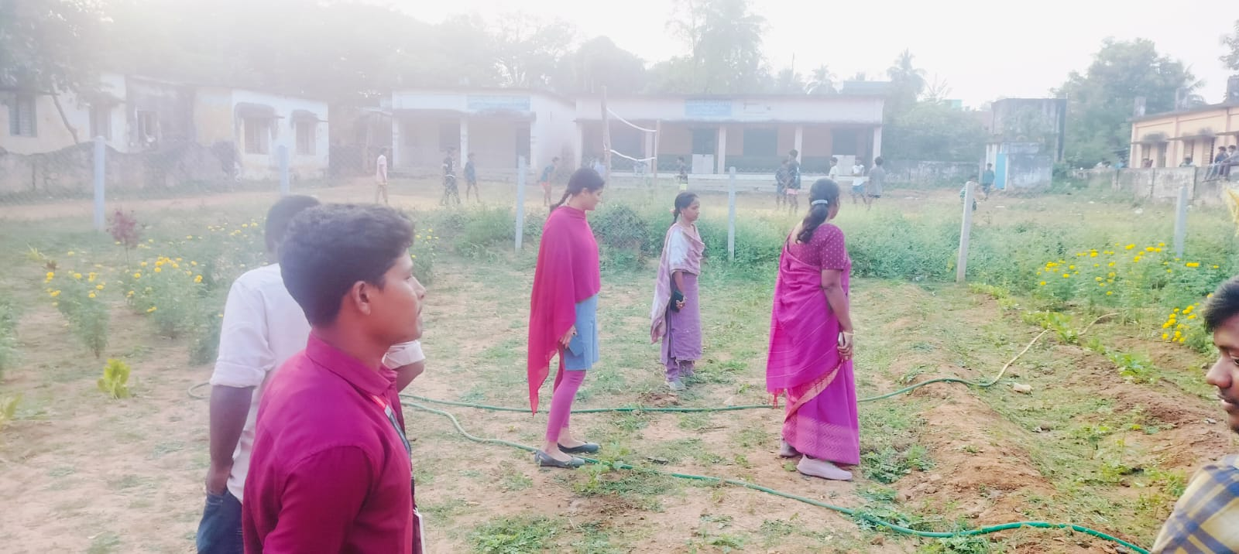

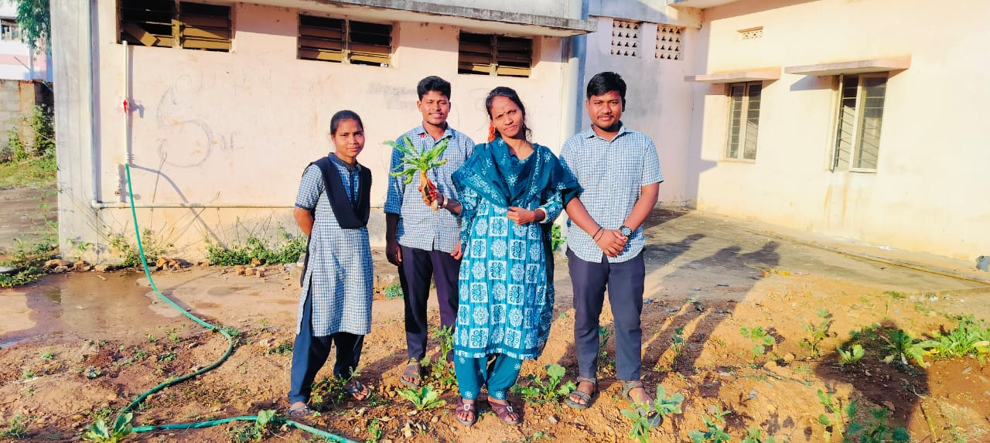

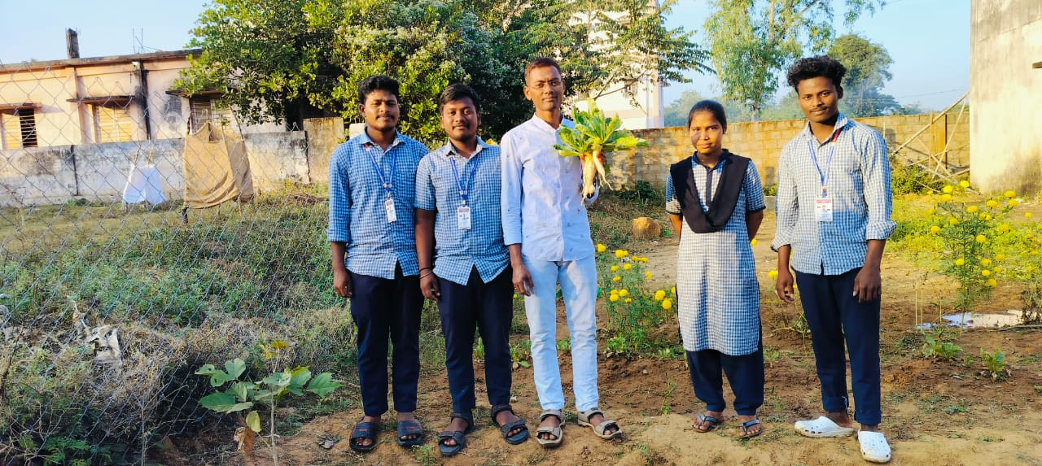

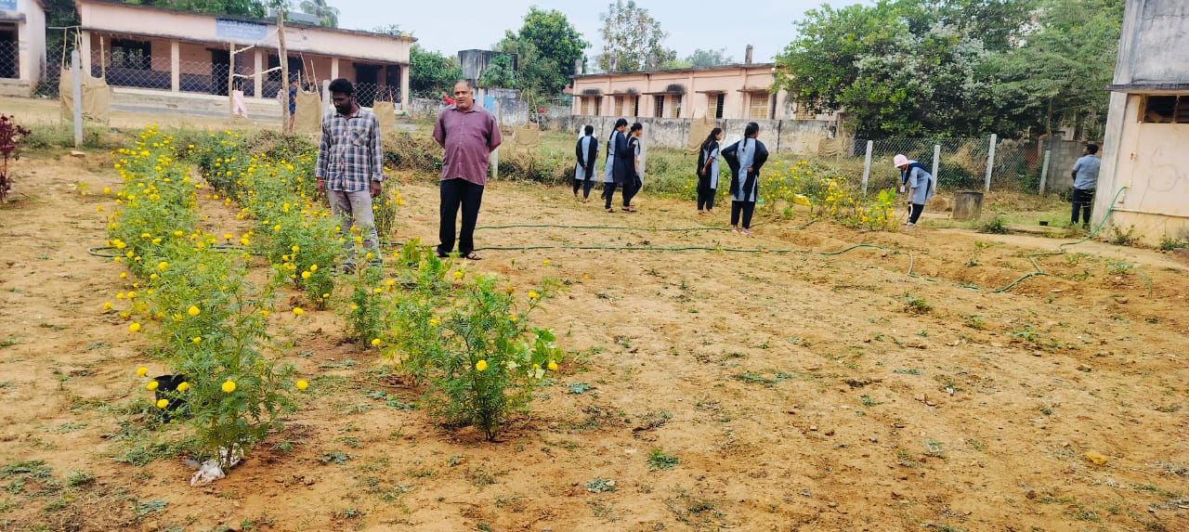

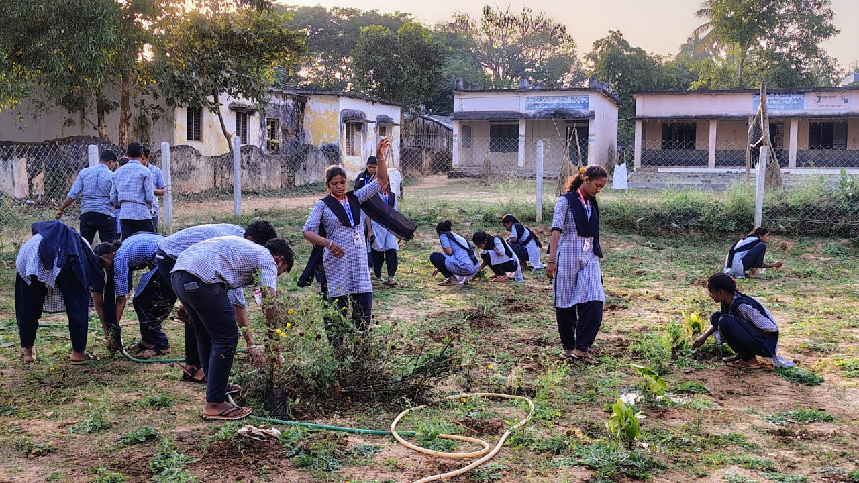

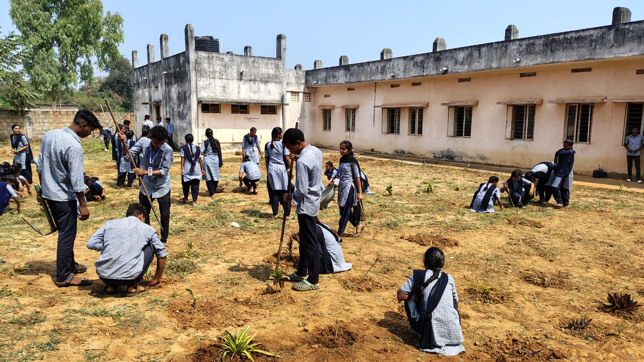

**Conclusion:**

**Kitchen Garden is now an important aspect of urban areas. It mostly helps to reduce kitchen waste and also helps to recycle kitchen waste water. By starting a kitchen garden and growing even a small portion of your own food, you’ll not only be cultivating a connection to what you eat, you’ll also be helping the planet. Not to mention the fact that it just feels good to have a hand in feeding yourself and your family. Plus it is a good exercise and reduces the stress.**

**Kitchen Gardening**

**Kitchen Gardening**